MOUNT BARKER TOURIST BUREAU (Inc)
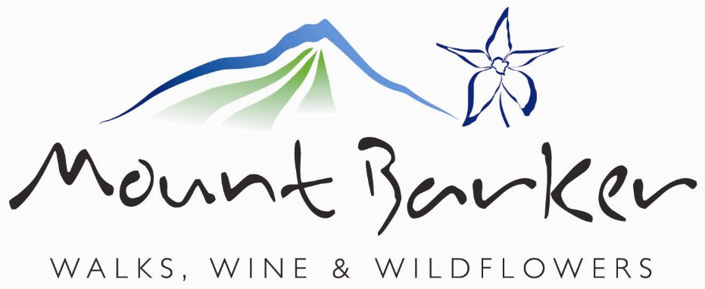 | TAX INVOICE  PO Box 441, Mt Barker WA 6324 Ph: 08 9851 1163  ABN: 661 898 177 14 | 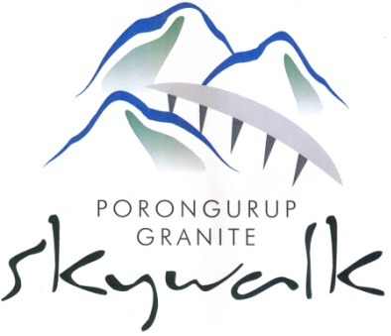
Email: secretary@mbtbwa.org.au
MEMBERSHIP APPLICATION/RENEWAL/UPGRADE
1 July 2015 to 30 June 2016

SECTION A – To be completed by all applicants please.
(SECTION B – To be completed by FULL and SPONSOR members only.)
Business/Property Name:
Contact Name:
Postal Address:
Town/City: |  |  |  |  |  |  |  |  |  | Postcode:
Business Address:
Town/City: |  |  |  |  |  | Postcode:
Phone: |  |  |  |  |  | Fax:
Mobile: |  |  |  | Email:
ABN: |  |  |  | Website:
Are you:  (Type/Print Y) |  | New member |  |  | Renewing member |  |  |  | Upgrading  member

MEMBER LEVEL | BENEFITS PACKAGE | COST | SELECT OPTION  Type/Print YES
SPONSOR | FULL membership entitlements plus one cubic metre display space in the Visitor Centre for promotional display for one month. Banner space in VC for the year. First option to rent outside banner at visitor centre (limited spaces, cost is extra). | $375.00
FULL | ASSOCIATE membership entitlements plus full website advertising in the Accommodation, Restaurant/Cafe, Winery/Vineyard and/or Businesses pages. Familiarity Tours. | $220.00
ASSOCIATE | Brochure display (includes Racking Fee),reduced cost to advertise in Visitor Guide, network event invitations. Priority text listing in our Website Business Directory. | $110.00
PRIVATE | Covers singles and couples. Network event invitations | $55.00
Direct Payment: Mount Barker Tourist Bureau: Bendigo Bank, BSB 633000. Account 115364578
Please show Member-<Your Name> in payment narration when making your direct payment.
Postal Payment: Mount Barker Tourist Bureau: PO Box 441, Mt Barker WA 6324
IMPORTANT NOTES:
COST - Full price to 31 December, Half price thereafter – Members wishing to upgrade pay the difference between their original and new levels on a full/half basis. Downgrading is not available.
WEBSITE LISTING AND FACEBOOK PROMOTION - Available with SPONSOR and FULL member levels – SPONSOR AND FULL MEMBERS - PLEASE COMPLETE SECTION B (Page 2) to expedite your website listing and Facebook promotion.
CHANGING MEMBERSHIP – Upgrades at any time, downgrades only on yearly renewal.
SECTION B – To be completed by FULL and SPONSOR members only
Please contact our I.T. Portfolio Manager – Colin Molloy on 0467 300 667 if you have any questions.
FACEBOOK PROMOTION – Do you have a Facebook page?
 | NO
 | YES - address
WEBSITE PROMOTION – Do you want your business promoted on our website?
 | NO – No further action required with SECTION B.
 | YES
ACCOMMODATION – Does your business provide accommodation?
 | NO – No further action required with ACCOMMODATION.
 | YES – Which category/ies best describe your accommodation – you can select more than one.
 | ←Backpackers |  |  | ←Bed & Breakfast |  |  | ←Cabins |  | ←Caravan Park
 | ←Chalet |  |  | ←Cottage |  |  | ←Farm Stay |  | ←Guest House
 | ←Hotel |  |  | ←Lodge |  |  | ←Motel |  | ←Vineyard Stay
Description - you can have a short (300 letter including spaces) description – please add below:
IMAGES – You can have up to four (4) images displayed – please email your application and your images to secretary@mbtbwa.org.au - no images will be displayed if not received.
FOOD – do you serve food/beverages – If YES, please complete this section.
Name of Café / Restaurant etc
Open Days / Times
Closed Days / Times
Description - you can have a short (300 letter including spaces) description – please add below:
WINERY / VINEYARD – are you a Winery/Vineyard? – If YES, please complete this section.
Name of Winery / Vineyard
Cellar Open Days / Times
Cellar Closed Days / Times
Description - you can have a short (300 letter including spaces) description – please add below:
BUSINESS – do you run a business that is none of the above? If YES, please complete this section.
Name of Business
Hours of Operation
Description - you can have a short (300 letter including spaces) description – please add below:
IMAGES – You can have up to four (4) images displayed – please email your application and your images to secretary@mbtbwa.org.au - no images will be displayed if not received.

